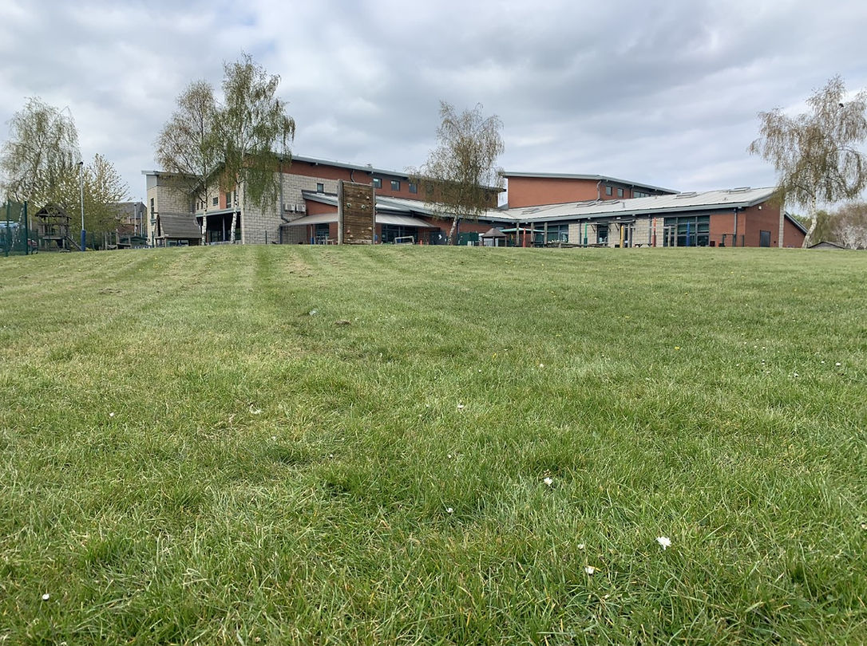
Welcome to Ferham Primary School

We are looking forward to working together with you and your child.

Here are the staff that will be working in your child’s class:
Mrs Scott Mrs Frost
Class Teacher Teaching Assistant
Miss Trnovska Mrs Booth
Teaching Assistant Teaching Assistant

Here are some other people that you and your child may see each day:
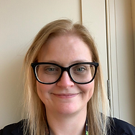
Mrs Fenton Mrs Bradley
Headteacher Deputy Head Teacher

Mr Tomlinson Mr Miker
Pastoral Lead EAL Champion

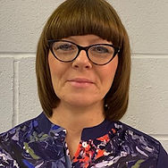
Mrs Nurse Mrs Roberts
Early Years Leader Safeguarding
Champion
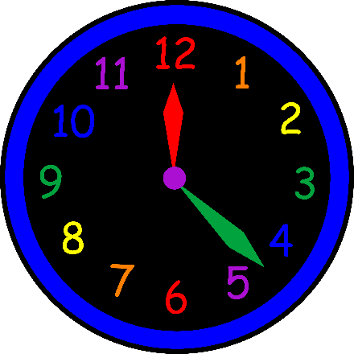
School Times
Gates open at 8.30am
School starts at 8.40am
School ends at 3.15pm
Children will be welcomed at the gate (to the right of the building). The gates open at 8.30am and close at 8.38am. Please ensure you child is on time each day.
Your child will miss out on important learning and routines if they are not at school on time.
At home time children will be called out to you on the playground one at a time. Please be patient this can take some time at first. The children’s safety comes first and we need to ensure everyone goes with the right adult.

If someone else will be collecting your child, please let us know. We will not let your child go with anyone other than you unless we have been told otherwise.

Snack
All children will have a snack mid-morning and be offered fruit and milk or water. Please don’t send your child to school with any snacks.

Lunch Times
Children have a choice of bringing a packed lunch or having a hot dinner. Packed lunches need to be healthy. No sweets, chocolate or fizzy drinks please. No nuts or spreads with nuts in please.
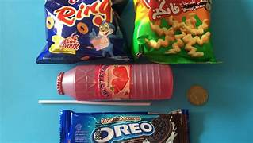
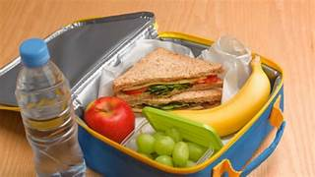
School dinners are free to all children in FS2, Year 1 and Year 2.

School Uniform
Children need to be in school uniform every day. This is a white polo shirt, a blue cardigan or jumper and grey or black trousers, skirts or dresses.

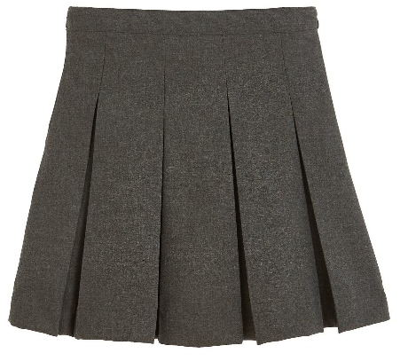
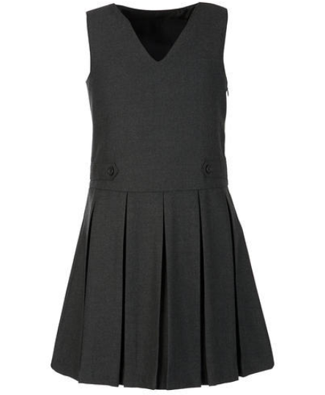
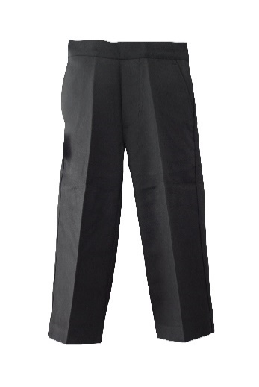
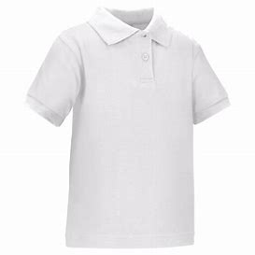

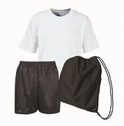
PE Kit

All uniform needs to be labelled with your child’s name.

No jewellery (necklaces, bracelets, rings, dangly earrings).
Only a small pair of stud earring allowed. Children coming to school in jewellery will be asked to remove it at the gate.
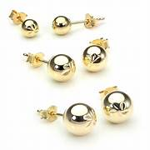

Your child will need to bring the following things to school each day:
A water bottle with their name on.

A coat suitable for the weather.
A book bag.

A bag with spare clothes and a pack of baby wipes.

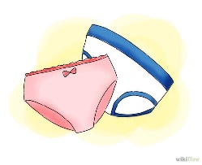
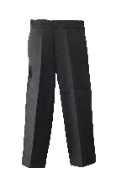
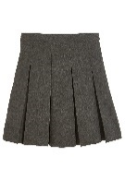

Absences
If your child is ill and will not be attending school, please telephone the school office prior to school starting.
If your child returns to school and is needing medication, please be aware we are only able to administer prescribed medicines. You will need to go to the office to fill in a form to give us permission to do this.

The Early Years Foundation Stage Curriculum
Our Curriculum is play based and linked to the 7 areas of
the EYFS curriculum. We aim to make our curriculum as fun and as engaging as we can. We carefully plan both indoor and outdoor opportunities to meet the needs of all individual children. We have a balance of adult and child led activities.
Here are the areas of learning:
- Communication and Language
- Personal, Social and Emotional Development
- Physical Development
- Literacy
- Mathematics
- Understanding the World
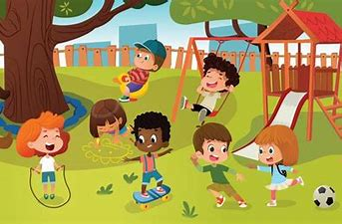
- Expressive Arts and Design

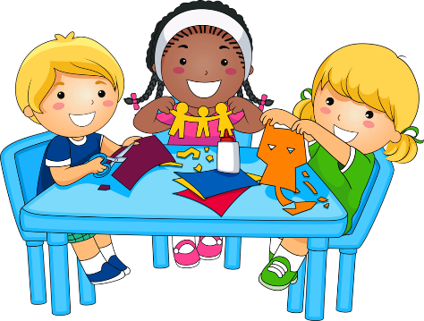

Working together
We believe that you are your child’s first educator and we want to work together with you to give your child the best possible start in school.
Here are some ways we will stay in touch and keep you informed:
Class Dojo – When your child starts school we will give you the details to log into this app. We will post things that are happening in school and in class on here. We can also send private messages on here. When your child first starts school we will try to send photographs to show they are happy and settled.
Letters
We will send letters to keep you informed.

Twitter
We have a school twitter account and regularly post photographs of exciting things happening in school.
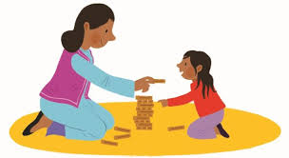
Stay and Play
Once the children have settled into school we will be inviting you to regular Stay and Play sessions. This is a lovely opportunity to see the activities on offer and to play with your child.

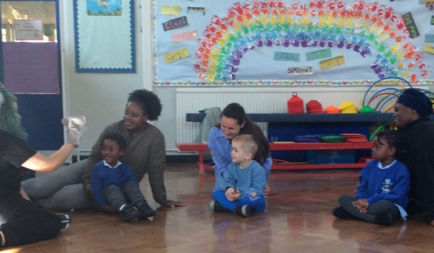
Parent Workshops
Over the year we will be holding workshops to provide you with more information on what your child will be learning and how you can support them at home.

We look forward to working with you and your child. Any questions, please don’t hesitate to contact us.
Thank you

Tel: 01709 740962
Email: school@fep.jmat.org.uk
Twitter: @PrimaryFerham

