

The ‘local offer’ for Rotherham will give you information regarding the services available locally.   
The Local Offer: <http://www.rotherhamsendlocaloffer.org>   
Link to SEND Policy: <https://www.ferhamprimary.org.uk/policies>

Ferham Primary School   
SEN Information Report

**Contact details:**

The Special Needs and Disabilities Co-ordinator (SENDCO) is **Mrs Emma Bradley**The Special Needs and Disabilities Governor is **XXX**

**01709 740962**

**How do we approach teaching children with SEND?**

In line with the 2014 SEND Code of Practice, the school promotes high quality first teaching in class. Children with SEND are supported in a variety of ways including: differentiated activities tailored to their needs, support from the class teacher or teaching assistant, the use of specialist equipment and small group or individual interventions to achieve specific outcomes.

We provide interventions that match children’s needs including Learning Support Programmes, Reading Rescue, Phonics sessions, Talking Partners, Talk Boost and motor skills groups. We also have learning mentors who work with children who need support with their social, emotional and mental health development. Where a child has an Education and Health Care Plan support is provided in line with the recommended provision.

**How do we assess and review the progress of children with SEND?**

Children with SEND have an IEP (Individual Education Plan) a LSP (Learning Support Plan – written by a Learning Support Teacher) or a SEN Support Plan. The IEPs, LSPs and Support Plans are reviewed termly with parents/carers and any external agencies involved. In addition to this, class teachers meet termly with the Senior Leadership Team to discuss the progress of every child, the impact of interventions and plan the next steps for the new term. These are called ‘pupil progress meetings’. A provision map is also devised termly which details all the intervention programmes in place to narrow the gap in learning for identified children.

**How do we adapt the curriculum and learning environment to suit children with SEND?**

The curriculum is adapted to meet the needs of all children. Class teachers make sure children can access the curriculum by differentiating planning within quality first teaching and provide learning activities that are appropriately challenging. Where appropriate, children may have access to special equipment such as, pencil grips, writing slopes, move ‘n’ sit cushions and personal visual timetables and workstations.   
The school building is fully accessible for wheelchairs and walking frames. We work closely with children, parents/carers and medical professionals to ensure the classroom layout and seating arrangements suit children with Visual or Hearing impairments. We are able to provide a supportive area for children who need relaxation time and/or positive play to meet social and emotional needs.

Ferham Primary School is committed to providing equal learning opportunities for all our children regardless of race, gender, special educational needs and/or disabilities (SEND).

We aim to provide provision for children who have various needs including children with:

* Communication and Interaction Needs (Autistic Spectrum Condition and Speech, Language and Communication Needs)
* Cognition and Learning Needs (Moderate or specific learning needs)
* Social, Emotional and Mental Health Needs
* Sensory and Physical Needs (Hearing, Visual and Multi-Sensory Impairment needs)

**How do we identify children with SEND?**

A pupil has SEND where their learning difficulty or disability calls for special educational provision, namely provision different from or additional to that normally available to pupils of the same age. Through communicating regularly with parents, we aim to work together to identify any SEND as early as possible and take appropriate action to support pupils. Every child in school has their progress closely monitored through regular pupil progress meetings and frequent consultation with parents/ carers. Children who are not making expected progress are highlighted and interventions or additional support are allocated depending on need.

Children will be identified as needing extra support if, despite high quality teaching, their progress is:

* Significantly slower than that of their peers starting from the same baseline.
* Fails to match or better the child’s previous rate of progress.
* Fails to close the attainment gap between the child and their peers.
* Widens the attainment gap.

It can include progress in areas other than attainment, for instance where a pupil needs to make additional progress with wider development or social needs in order to make a successful transition to adult life.

**How do we evaluate the effectiveness of provision for children with SEND?**

In addition to the review schedule, parent’s consultation evenings, pupil progress meetings and planning meetings with external services, the school also continually reflects and reviews its practice. Class teachers routinely evaluate their teaching and the impact of strategies or interventions that have been used. Teachers and teaching assistants collaborate and work to provide the best support for all children. Where particular strategies are not working, further advice is sought from the SENDCO or specialist services.

**How do we consult with parents/carers of children with SEND?**

Parents/carers are welcomed into our school and their views are valued. Parents/carers of children with SEND are invited to take part in termly review meetings for their child with the SENDCO, Class Teacher and any agency involved to discuss current support and the impact any intervention and plan the next steps. Parents/carers evenings are also held for all children each term.

**How do we consult with children with SEND?**

At Ferham Primary School we gather children’s views prior to review meetings to ensure their views are voiced during the review process. We encourage children to share their views about their strengths and areas for development, our school, how they view the support they are getting and what support they think they would benefit from.

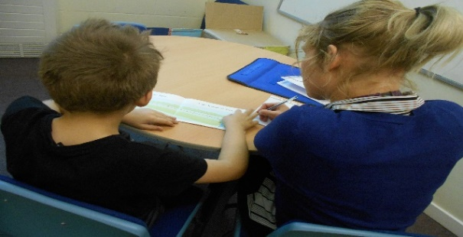

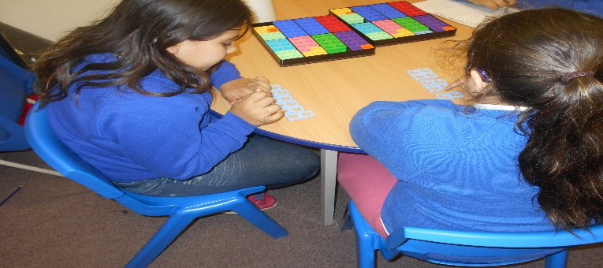

**How are children supported in their emotional and social development?**

Our school employs two Learning Mentors who are able to provide pastoral support. A range of support strategies are in place for children who need them including 1:1 time to talk sessions, group work and relaxation time. The school prides itself on working closely with families and other agencies to provide the best outcomes for children in their educational, social and emotional development. We also works closely with the Early Help Team when such support is needed.

**How does the expertise and training of staff help support children with SEND and how do we secure specialist expertise?**All staff, as part of their professional development, receive training to assist in supporting children of all abilities. We provide staff with training that is relevant to the current needs of the school. This may be from Learning Support Services, the Hearing/Visual Impaired Team, Speech and Language Therapy Team or other relevant services. Teaching assistants are provided with training that will enable them to deliver interventions. We have teaching assistants who have been trained to deliver programmes such as Talk Boost and Reading Rescue. We have Learning Mentors who are highly skilled in supporting children with social emotional and mental health (SEMH) needs. The SENDCO attends network meetings organised by the local authority and regular learning community meetings.   
The school purchases time from the Learning Support Service (LSS) and Educational Psychology (EPS). We also use specialist advice from the Speech and Language Team, Visual Impairment Team, Hearing Impaired Team, Physiotherapists, Occupational Therapists and CAMHS as required. In the Early years, specialist advice is sought through Health Visitors and the Early Years Learning Support Services where required.The designated teacher for Looked After Children will liaise with the SENDCO to ensure that the needs of children with SEND, who are looked after, are met.

**How do we support transition arrangements for children?**

For children arriving in Early Years Foundation Stage, we consult with parents/carers about any SEND provision required. Children are invited to settling in sessions. Throughout school, we provide opportunities for all children to spend time in their new class early before the summer. Children with special educational needs and/or disabilities (SEND) may also have extra visits to new classes where appropriate. Receiving class teachers may also attend the summer review meetings.

When children are transferring to their secondary school they start transition at the beginning of year six with visits to the school. Y6 children access the “Bridging Project” which provides additional sessions for identified children. The children are familiar with comprehensive staff as they are regular visitors to school. In addition to this, representatives from the comprehensive setting the child is moving on to are invited to attend the SEND reviews for children in Y5 and Y6. The SENDCO will complete the necessary transition documents and arrange the transfer of all relevant documentation.

If children join us from other settings, we will consult with parents/carers about any SEND provision required and strive to obtain any relevant information from the previous school.

**Procedures for complaints relating to SEND provision:**

Ferham Primary School seeks to promote cooperation between parents and multi-agency professionals to enable children to achieve their full potential.

The school has a complaints policy which is available on the school website.

Any complaints can be discussed with the Class Teacher, SENDCO or the Headteacher. The SEND Governor can also be contacted through appointment or in writing.

**How do children with SEND engage with children without SEND?**

Children with SEND are involved in all activities in our school. If required, individual risk assessments are completed and shared with those leading visits or activities.