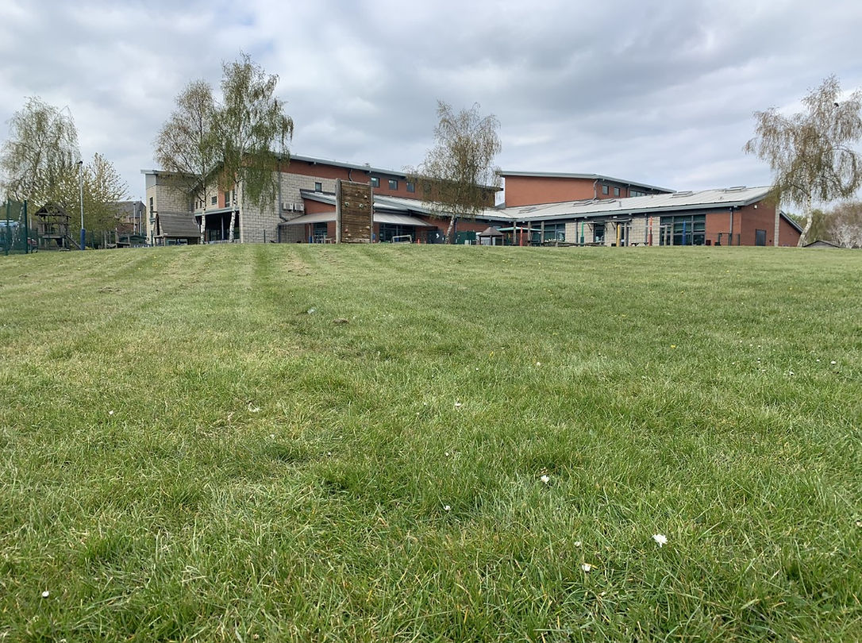
Welcome to Ferham Nursery

We are looking forward to working together with you and your child.

Here are the staff that will be working in Nursery with your child:
Mrs Nurse Mrs Lindley
Class Teacher Teaching Assistant and Early Years
Leader
Miss Jeffcock
Teaching Assistant

Here are some other people that you and your child may see each day:
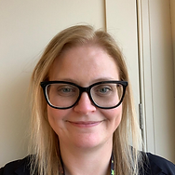
Mrs Fenton Mrs Bradley
Headteacher Deputy Head Teacher

Mr Tomlinson Mr Miker
Pastoral Lead EAL Champion

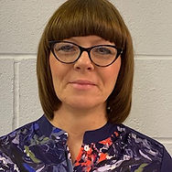

Mrs Roberts
Safeguarding Champion

Eligibility
All children are entitled to 15 hours free child care from the term after their third birthday. Some children may be eligible for 30 hours (please see https://www.gov.uk/30-hours-free-childcare)
Some children will be eligible for 15 hours childcare the term after they turn two (please see https://www.gov.uk/help-with-childcare-costs/free-childcare-2-year-olds).

What we offer at Ferham
If your child is two and eligible for funding, we offer up to 5 afternoon sessions 12.15-3.15pm.
The term after they turn three they will be offered a morning place.
If your child is three, then the term after their birthday we offer up to 5 morning sessions 8.40-11.40am.

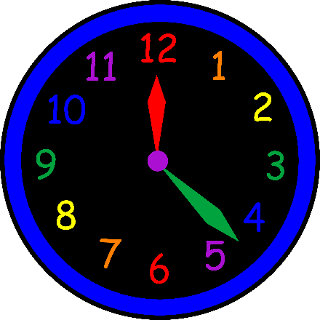
Welcome Time
Children will be welcomed at the gate (to the right of the building). The gates open at 8.30am and close at 8.38am. Please ensure you child is on time each day. If your child is attending the afternoon session, we open the gates at 12.15pm.

Please ensure your child is on time each day so they do not miss out on important learning and routines.
At home time, we will open the gates for you to come up to the entrance. Children will be called out one at a time. Please be patient as this can take some time at first. The children’s safety comes first and we need to ensure everyone goes with the right adult.

If someone else will be collecting your child, please let us know. We will not let your child go with anyone other than you unless we have been told otherwise.

Snack
All children will have a snack mid-morning or mid-afternoon and be offered fruit and milk or water. Please don’t send your child to school with any snacks.

What to Wear
The children in Nursery do not need to wear uniform, however if you would like them to the rest of the school wear a white polo shirt, a blue cardigan or jumper and grey or black trousers, skirts or dresses.
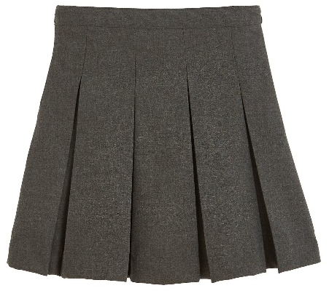
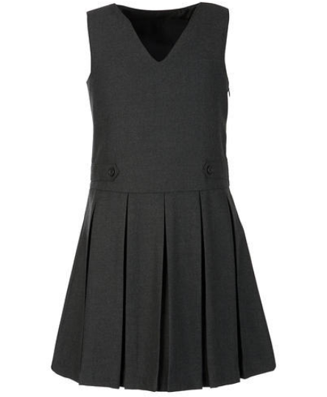
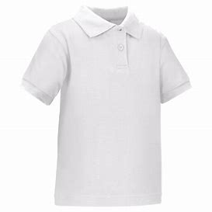

Please do not send children in their newest or their ‘best’ clothes. The children play in water, paint, messy activities and outside daily. Their clothes will come home dirty from time to time.
All belongings need to be labelled with your child’s name.
No jewellery (necklaces, bracelets, rings, dangly earrings).
Only a small pair of stud earring allowed. Children coming to school in jewellery will be asked to remove it at the gate.

Your child will need to bring the following things to school each day:
A coat suitable for the weather.
A book bag.

A bag with spare clothes and a pack of baby wipes.
Spare nappies or pull ups and nappy sacks if they are not yet toilet trained.

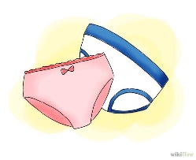
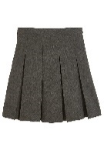

Absences
If your child is ill and will not be attending school, please telephone the school office prior to school starting.
If your child returns to school and is needing medication, please be aware we are only able to administer prescribed medicines. You will need to go to the office to fill in a form to give us permission to do this.

The Early Years Foundation Stage Curriculum
Our Curriculum is play based and linked to the 7 areas of
the EYFS curriculum. We aim to make our curriculum as fun and as engaging as we can. We carefully plan both indoor and outdoor opportunities to meet the needs of all individual children. We have a balance of adult and child led activities.
Here are the areas of learning:
- Communication and Language
- Personal, Social and Emotional Development
- Physical Development
- Literacy
- Mathematics
- Understanding the World
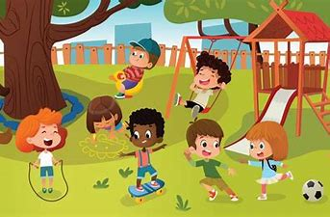
- Expressive Arts and Design

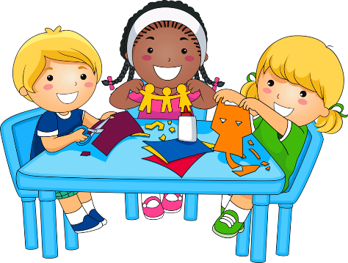

Key Person
When your child starts Nursery they will be given a ‘Key Person.’ We will let you know who this is as they start.
This person will help your child to settle and will build a relationship with them. They will also play an active role in your child’s learning and development.
Working together
We believe that you are your child’s first educator and we want to work together with you to give your child the best possible start in school.
Here are some ways we will stay in touch and keep you informed:
Class Dojo – When your child starts school we will give you the details to log into this app. We will post things that are happening in school and in class on here. We can also send private messages on here. When your child first starts school we will try to send photographs to show they are happy and settled.
Letters
We will send letters to keep you informed.

Twitter
We have a school twitter account and regularly post photographs of exciting things happening in school.
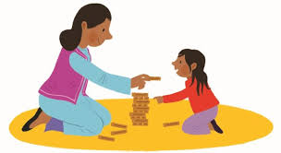
Stay and Play
Once the children have settled into school we will be inviting you to regular Stay and Play sessions. This is a lovely opportunity to see the activities on offer and to play with your child.

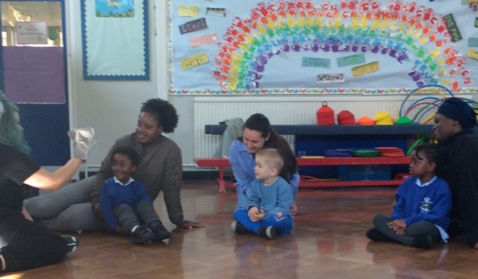
Parent Workshops
Over the year we will be holding workshops to provide you with more information on what your child will be learning and how you can support them at home.

We look forward to working with you and your child. Any questions, please don’t hesitate to contact us.
Thank you

Tel: 01709 740962
Email: school@fep.jmat.org.uk
Twitter: @PrimaryFerham

